**CMOS vs TTL levels**

In the beginning there were the fast and power hungry bipolar TTL families 74xx (74Sxx, 74LSxx) and the complementary MOSFET family 4000-series which supported higher voltages, consumed less but were quite slow and not pin compatible with the 74xx. They invented the pin compatible 74Cxx CMOS family (4V - 15V), but at first with not much success because of the slow speed. Then came the faster and successful 74HCxx CMOS family (2V - 6V). Finally to make the input levels compatible with TTL they invented the 74HCTxx CMOS family (5V only) with TTL input levels and CMOS output levels.

CMOS ICs can feed TTLs without any problems:

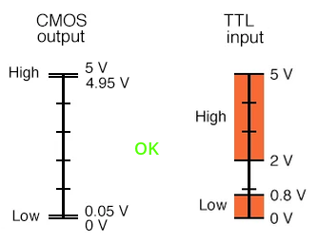

But a TTL cannot feed a CMOS IC:

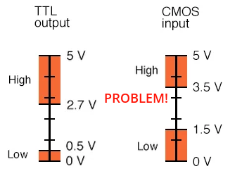

for this reason there are the mixed CMOS/TTL devices with a "T" in the part number which can be fed by both the classic TTLs and obviously also by the CMOS.

AVR microcontrollers are CMOS and work with CMOS voltage levels. So you can freely use 74HCxx and 74HCTxx chips with AVR inputs and outputs.